How to change Wi-Fi connection name

PC/Laptop
1. Switch your Wi-Fi connection to BellnetXXXXXX (By default your Q Station's Wi-Fi connection is something like this)
2. Access 172.16.0.1 with your Internet browser.
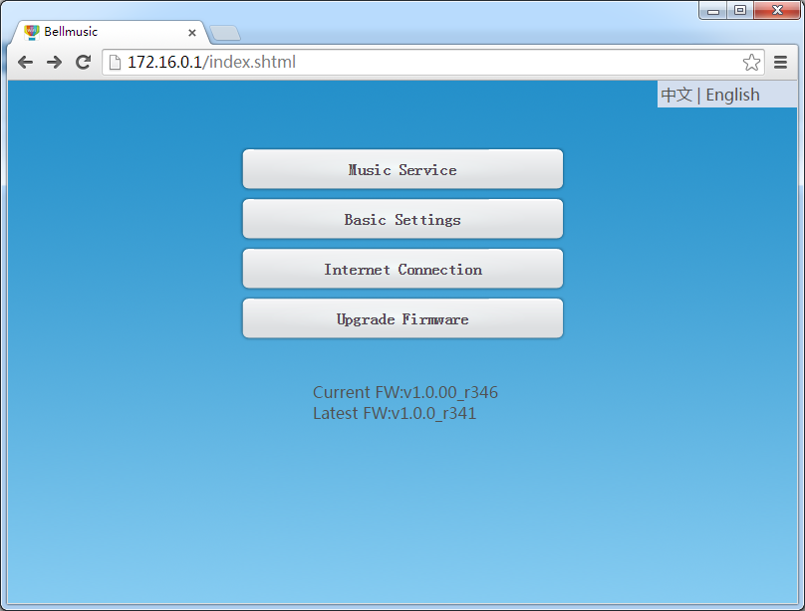
3. Click 'Basic Settings' to change the Wi-Fi name and then click Done button to take this change effect within 25 seconds.

IOS
1. Get 'bellq' from Apps Store and install it on your iPhone
2. Run BellQ and click setting icon
3. Click 'Basic Settings' and change Wi-Fi connection name, then click Done button to take this change effect.

Android
1. Get 'qlight' or 'bellq' from Google Play and install it on your Android smart phone (BellQ is our apps with full features supported)
2. Run Qlight or BellQ and click setting icon
3. Click 'Basic Settings' and change Wi-Fi connection name, then click Done button to take this change effect.

